**CONTROL SYSTEMS (5th EE & IE)**

**COMPUTER LABORATORY**

**ASSIGNMENT 3**

**Program 1:**

To create an M-file to calculate Mean and Standard Deviation of an input data set. Type the following and test the program:

n=0;

sum1=0;

sum2=0;

x=input('Enter first value:');

while x >= 0

n=n+1;

sum1=sum1+x;

sum2=sum2+x^2;

x=input('enter next value(enter -ve value to terminate):');

end

clc;

if n<2

disp('at least 2 values must be entered');

else

mean_x=sum1/n;

std_dev=sqrt((n*sum2-sum1^2)/(n*(n-1)));

fprintf('the mean of data set is : %f\n',mean_x);

fprintf('the standard deviation is : %f\n',std_dev);

fprintf('the number of data points is : %f\n',n);

end

**Input:**

Enter first value:45

enter next value(enter -ve value to terminate):67

enter next value(enter -ve value to terminate):89

enter next value(enter -ve value to terminate):34

enter next value(enter -ve value to terminate):90

enter next value(enter -ve value to terminate):12

enter next value(enter -ve value to terminate):-1

**Output:**

the mean of data set is : 56.166667

the standard deviation is : 31.326772

the number of data points is : 6.000000

**Program 2:**

Create an M-file with the following set of statements and study the time response of a second order system:

clear all;

t=0:.01:100;

wn=input ('Enter natural frequency wn:');

zeta=input('Enter damping ratio zeta:');

num=[wn^2];

den=[1 2*zeta*wn wn^2];

sys=tf(num,den);

y=step(sys,t);

plot(t,y);

**Input-Output:**

Enter natural frequency wn:0.5

Enter damping ratio zeta:0

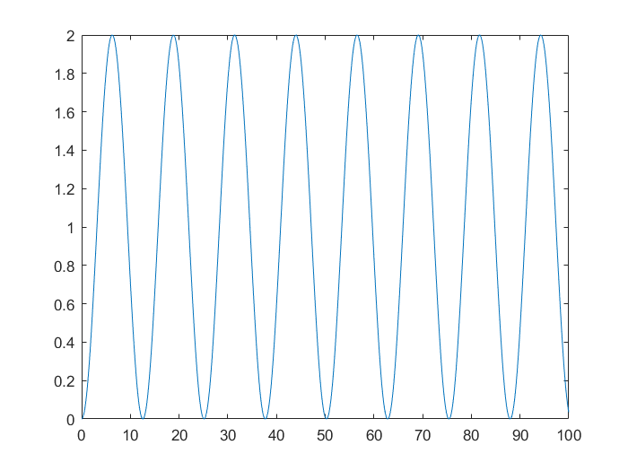

Enter natural frequency wn:5

Enter damping ratio zeta:0.1

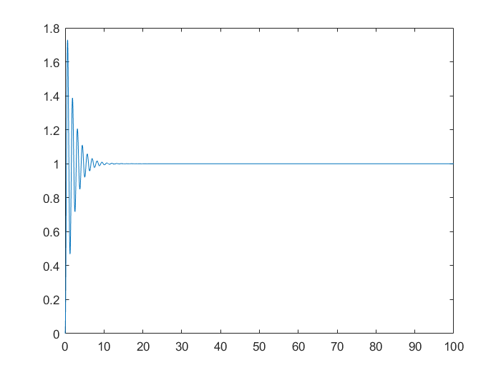

Enter natural frequency wn:5

Enter damping ratio zeta:1

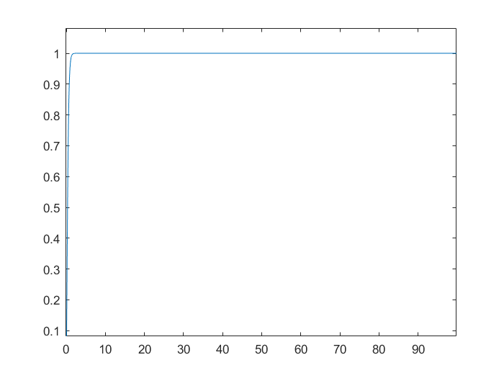

Enter natural frequency wn:5

Enter damping ratio zeta:5

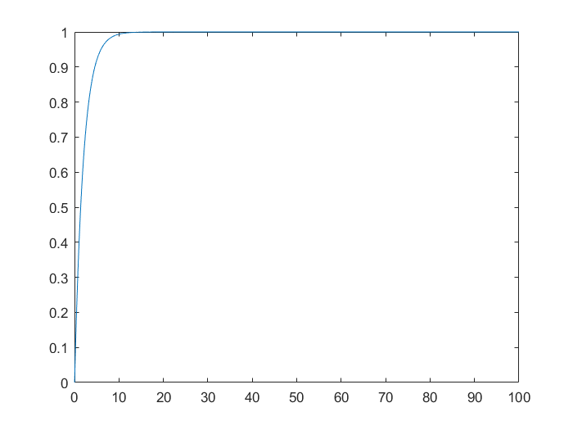

**Program 3:**

Create an M-file with the following set of statements and study the time response of a first order system:

clear;

pack;

clc;

T=input('Enter value of time constant T:');

num=[1];

den=[T 1];

t=0:1:14;

y=step(num,den,t);

plot(t,y);

xlabel('Time in seconds');

ylabel('Output y');

title('Unit-step response of first order system');

**Input-Output:**

Enter value of time constant T:1

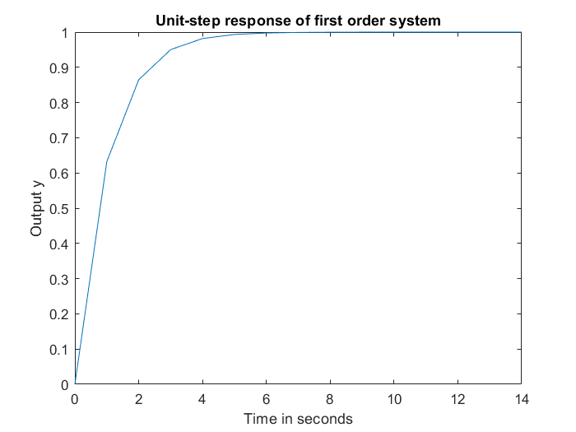

Enter value of time constant T:5

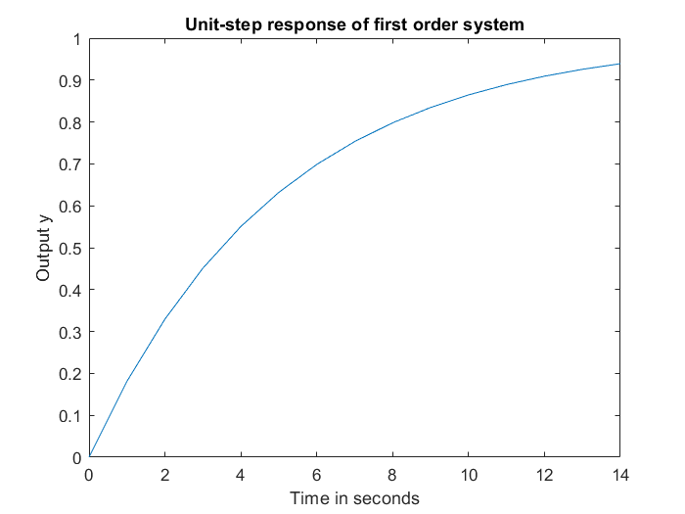

Enter value of time constant T:10

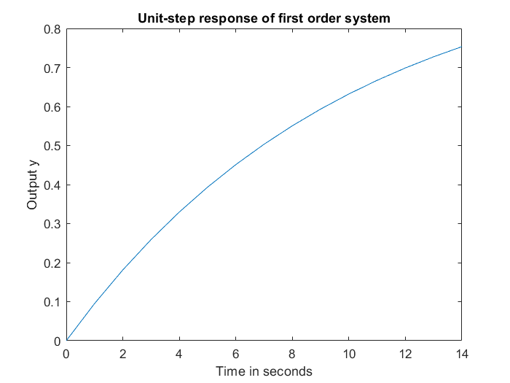

**Program 4:**

Create an M-file with the following set of statements and study the transient response of a 2nd order system with varying damping ratio and constant natural frequency:

clear;

pack;

clc;

j=1;

wn=1;

while(j<6)

zeta(j)=input('Enter value of damping ratio:');

num=[wn*wn];

t=0:0.1:26;

den=[1 2*zeta(j)*wn wn*wn];

[y,x,t]=step(num,den,t);

%calculation of rise time(10% to 90% criterion)

i=1;

while y(i)<.1

i=i+1;

end

ten=t(i);

while y(i)<0.9

i=i+1;

end

ninety=t(i);

Tr(j)=ninety-ten;

%calculation of delay time

i=1;

while y(i)<0.5

i=i+1;

end

Td(j)=t(i);

%calculation of maximum overshoot and corresponding time (peak time)

for i=2:1:260

if y(i)<=y(i-1)

break;

end

end

Mp(j)=y(i)-y(260);

Tp(j)=t(i);

%calculation of settling time using 5% criterion

ts = 0.05;

i=2;

for i=260:-1:2

if (abs(y(i)-y(260)))>=0.05

break;

end

end

Ts(j)=t(i);

%Plotting of graphs

step(num,den,t);

axis([0 30 0 1.6]);

title('Unit step response of 2nd order system with varying zeta and constant wn');

pop1 = sprintf('%6.3g',zeta(j));

text(t(40),y(40),pop1);

hold on;

j=j+1;

end

%Display of results

j=1;

while(j<6)

pop=sprintf('%1.3g %6.3g %6.3g %6.3g %6.3g %6.3g',zeta(j),Td(j),Tr(j),Ts(j),Mp(j),Tp(j));

text(10,.8,'Zeta Td Tr Ts Mp Tp');

text(10,.8-(.1*j),pop);

j=j+1;

end

**Input:**

Enter value of damping ratio:0

Enter value of damping ratio:0.2

Enter value of damping ratio:0.5

Enter value of damping ratio:1

Enter value of damping ratio:2

**Output:**

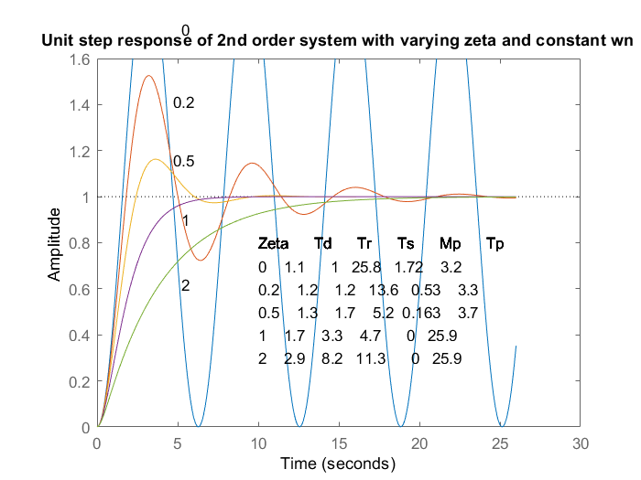

**Test:**

1. **A higher order system is defined by **

**Create an M-file to plot unit step response of the system and to obtain the peak time, maximum overshoot and settling time (5% criterion).**

Cs = [7 16 10];

Rs = [1 5 11 16 10];

t = 0:0.1:26;

[y,x,t]=step(Cs,Rs,t);

step(Cs,Rs,t);

%calculation of maximum overshoot and corresponding time (peak time)

for i=2:1:260

if y(i)<=y(i-1)

break;

end

end

Mp=y(i)-y(260);

Tp=t(i);

%calculation of settling time using 5% criterion

ts=0.05;

i=2;

for i=260:-1:2

if (abs(y(i)-y(260)))>=0.05

break;

end

end

Ts=t(i);

%Output

fprintf("Peak Time: %fs\n", Tp);

fprintf("Maximum Overshoot: %f\n", Mp);

fprintf("Settling Time: %fs\n", Ts);

**Output:**

Peak Time: 1.600000s

Maximum Overshoot: 0.534905

Settling Time: 5.400000s

